HOTEL RESERVATION SYSTEM
Project Documentation
Submitted By
Name: Kamalesh S
Designation: Java Developer
EMP i’d:STK-26-2852
1. Project Overview
The Hotel Reservation System is a RESTful web application developed using Java and Spring Boot. It is designed to manage hotel customers, rooms, room types, reservations, payments, and room amenities.
The application provides REST APIs for creating and managing hotel data. It also includes room availability checking, reservation date validation, double-booking prevention, payment validation, and customer reservation history.

2.Objectives
- Manage customer information.
- Manage room types and rooms.
- Check room availability for selected dates.
- Create, update, and cancel reservations.
- Prevent overlapping room reservations.
- Calculate reservation total amount.
- Manage payments.
- Manage room amenities.
- Provide API documentation using Swagger.
- Handle validation and application exceptions.

3. Technologies Used
Technology | Purpose
Java 21 | Programming
Spring Boot | Backend framework
Spring Data JPA | Database operations
Hibernate | ORM
MySQL | Database
Maven | Build and dependency management
Lombok | Reduce boilerplate code
Bean Validation | Input validation
Swagger/OpenAPI | API documentation
Postman | API testing
IntelliJ IDEA | Development

4. System Architecture
The project follows a layered architecture:
Client
↓
Controller
↓
Service
↓
Repository
↓
JPA / Hibernate
↓
MySQL Database
Main Layers
Controller: Handles REST API requests.
Service: Contains business logic.
Repository: Performs database operations.
Entity: Represents database tables.
DTO: Handles API request and response data.
Mapper: Converts Entity objects to DTOs and vice versa.
Exception: Handles application errors.

5. Project Structure
src/main/java/com/hotel/reservation
│
├── controller
├── service
├── repository
├── entity
├── dto
├── mapper
├── exception
└── config
The project also contains:
pom.xml
README.md
.gitignore

6. Modules
Customer
Stores customer name, email, and phone number.
Room Type
Stores room category, description, and base price.
Room
Stores room number, floor, status, room type, and amenities.
Reservation
Handles customer room bookings, dates, status, and total amount.
Payment
Handles payment amount, payment method, payment status, and payment date.
Amenity
Manages facilities such as WiFi and swimming pool.

7. Database Design
Database:
hotel_reservation_db
Tables:
customers
room_types
rooms
reservations
payments
amenities
room_amenities
Relationships
RoomType 1 ─────── * Room

Customer 1 ─────── * Reservation

Room 1 ─────────── * Reservation

Room * ─────────── * Amenity
The Room and Amenity many-to-many relationship is maintained using the room_amenities junction table.

8. REST API Documentation
Customer APIs
Method | Endpoint | Purpose
POST | /api/customers | Create customer
GET | /api/customers | Get all customers
GET | /api/customers/{id} | Get customer
PUT | /api/customers/{id} | Update customer
DELETE | /api/customers/{id} | Delete customer
Room Type APIs
Method | Endpoint | Purpose
POST | /api/room-types | Create room type
GET | /api/room-types | Get room types
GET | /api/room-types/{id} | Get room type
PUT | /api/room-types/{id} | Update room type
DELETE | /api/room-types/{id} | Delete room type
Room APIs
Method | Endpoint | Purpose
POST | /api/rooms | Create room
GET | /api/rooms | Get rooms
GET | /api/rooms/{id} | Get room
PUT | /api/rooms/{id} | Update room
DELETE | /api/rooms/{id} | Delete room
PUT | /api/rooms/{roomId}/amenities/{amenityId} | Add amenity
Reservation APIs
Method | Endpoint | Purpose
POST | /api/reservations | Create reservation
GET | /api/reservations/availability | Check availability
PUT | /api/reservations/{id} | Update reservation
PUT | /api/reservations/{id}/cancel | Cancel reservation
GET | /api/reservations/customer/{customerId} | Customer history
Payment APIs
Method | Endpoint | Purpose
POST | /api/payments | Create payment
GET | /api/payments/{id} | Get payment
Amenity APIs
Method | Endpoint | Purpose
POST | /api/amenities | Create amenity
GET | /api/amenities | Get amenities
GET | /api/amenities/{id} | Get amenity
PUT | /api/amenities/{id} | Update amenity
DELETE | /api/amenities/{id} | Delete amenity

9. Important Business Logic
Room Availability
The system checks existing confirmed reservations before creating a new reservation.
If the requested dates overlap with an existing confirmed reservation, the room is considered unavailable.
Date Validation
The check-in date must be before the check-out date.
Example:
Check-in : 2026-12-10
Check-out : 2026-12-05
The system returns:
400 Bad Request
Total Amount
The reservation amount is calculated as:
Total Amount = Room Base Price × Number of Nights
For example:
₹3000 × 4 nights = ₹12000
Payment Validation
Payment is accepted only for a confirmed reservation, and the payment amount must match the reservation total.

10. Validation and Exception Handling
The application uses Jakarta Bean Validation.
Examples:
@NotBlank
@NotNull
@Email
@Positive
@DecimalMin
Custom exceptions used:
ResourceNotFoundException
BusinessException
A global exception handler using @RestControllerAdvice provides structured error responses.

11. API Result
11.1 Swagger API Documentation
http://localhost:8081/swagger-ui/index.html
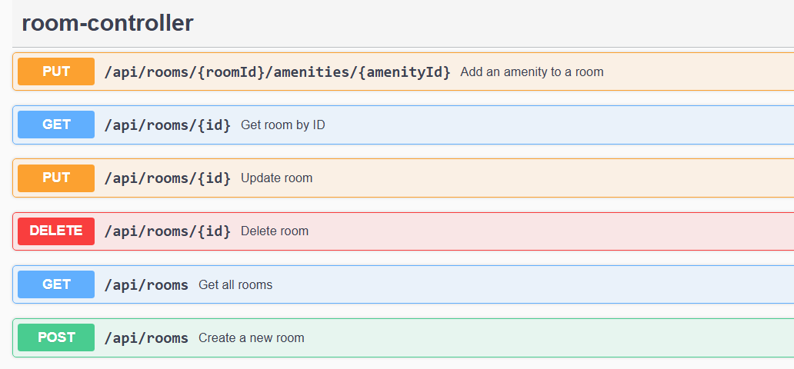
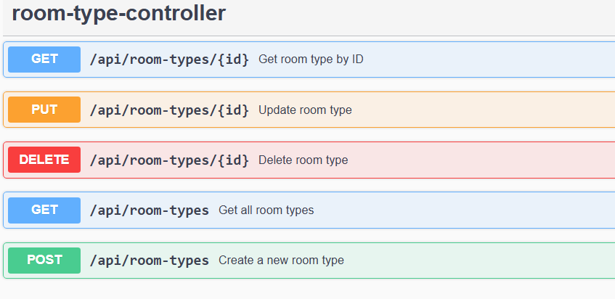
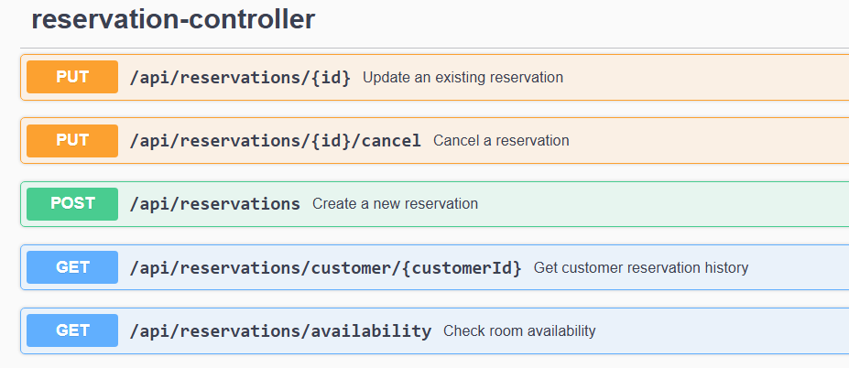
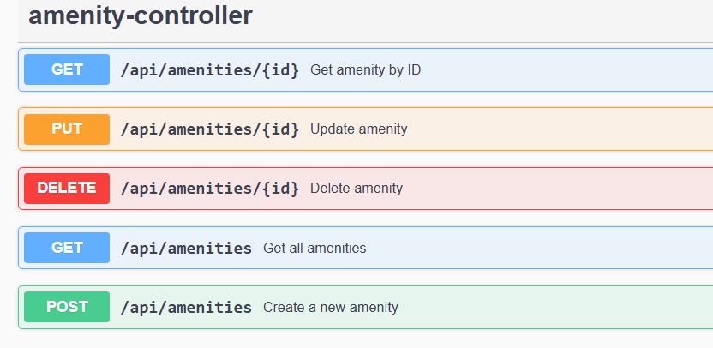

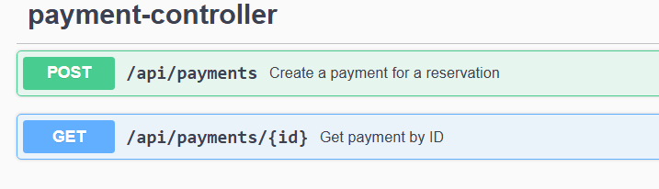
12. Create Room Type
Room Type → POST /api/room-types
Request body:
{
"typeName": "Premium",
"description": "Premium room with modern facilities",
"basePrice": 4000
}
Reponse body
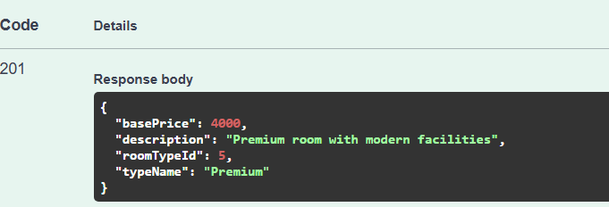
13. Create Customer
Go to:
Customer → POST /api/customers
Use:
{
"name": "Robert Kumar",
"email": "robert@example.com",
"phone": "9876543212"
}
Response body:
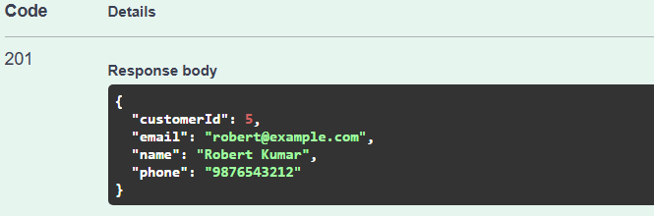

14. Create Room
Go to:
Room → POST /api/rooms
Use a new room number:
{
"roomNumber": "201",
"floor": 2,
"status": "AVAILABLE",
"roomTypeId": 1
}
Response Body:
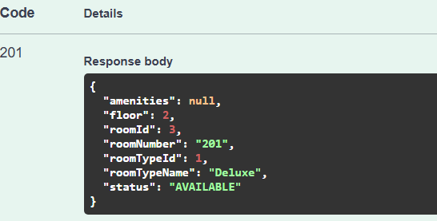

15. Create Amenity
Go to:
Amenity → POST /api/amenities
Use:
{
"name": "Air Conditioning",
"description": "Central air conditioning facility"
}
Response Body:
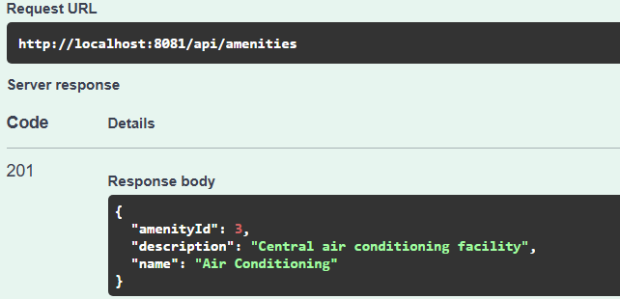
16. Add Amenity to Room
Go to:
Room → PUT /api/rooms/{roomId}/amenities/{amenityId}
For example, if:
roomId = 2
amenityId = 3
Response Body:
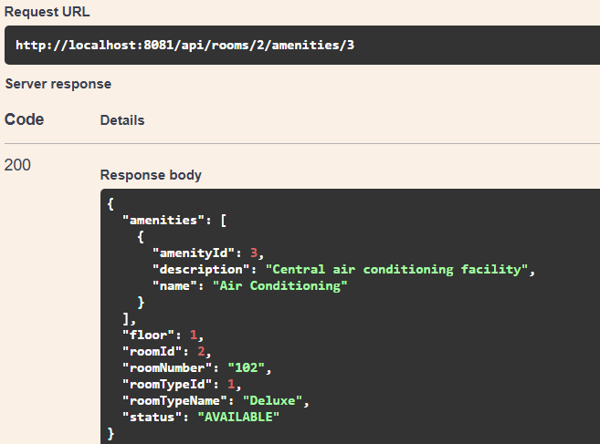
17. Check Room Availability
Go to:
Reservation → GET /api/reservations/availability
Response body:
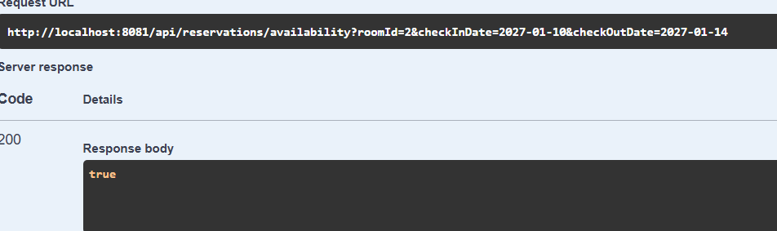
18. Create Reservation
Go to:
Reservation → POST /api/reservations
For example:
{
"customerId": 3,
"roomId": 2,
"checkInDate": "2027-01-10",
"checkOutDate": "2027-01-14"
}
Response body:
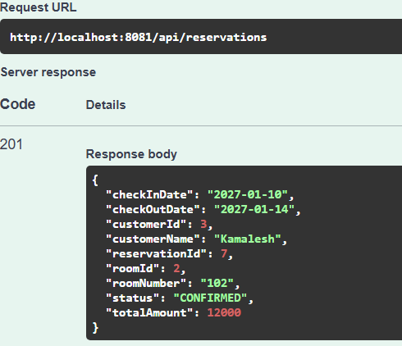
19. Update Reservation
Use the reservation ID from the previous step.
Go to:
Reservation → PUT /api/reservations/{id}
For example:
id = 6
Response body:
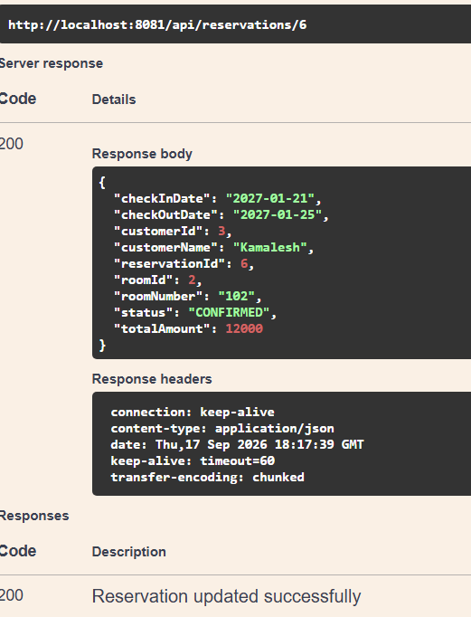
20. Create Payment
Go to:
Payment → POST /api/payments
For example:
{
"reservationId": 8,
"amount": 15000,
"paymentMethod": "UPI
Response Body:
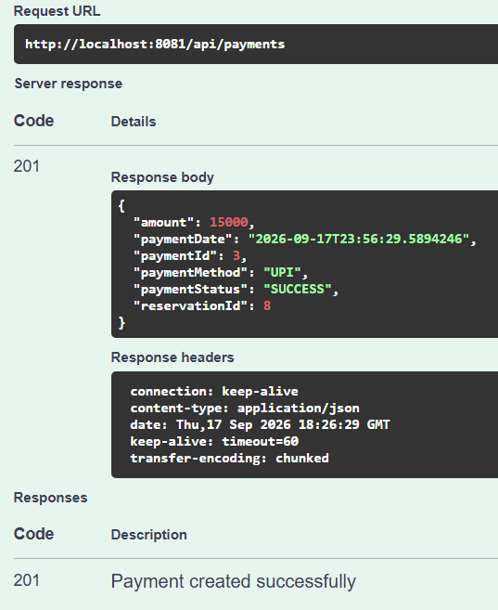
21. MySQL Database tables:
SHOW TABLES;
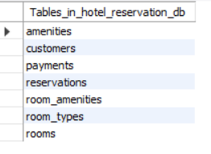
22. SELECT * FROM room_types;
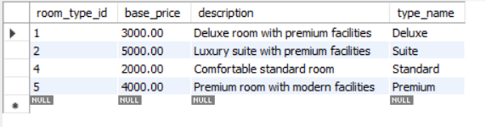
23. Customers
SELECT * FROM customers;
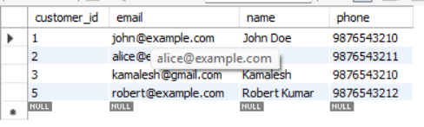
24. Rooms
SELECT * FROM rooms;
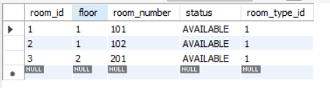
25.Reservations:
SELECT * FROM reservations;
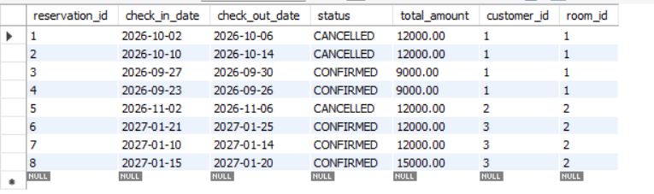
26.Payments:
SELECT * FROM payments;
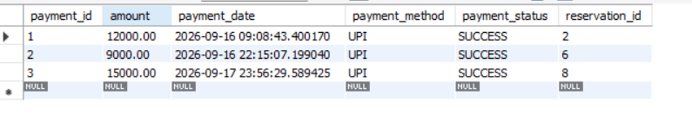
27.Amenities:
SELECT * FROM amenities;
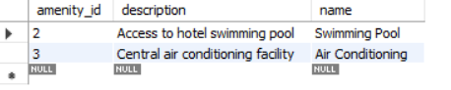
28. Room-Amenity relationship:
SELECT * FROM room_amenities;
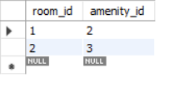
29. Conclusion
The Hotel Reservation System was successfully developed using Java, Spring Boot, Spring Data JPA, Hibernate, and MySQL.
The application provides APIs for customer, room, room type, reservation, payment, and amenity management. Important features such as room availability checking, date validation, reservation management, payment validation, and exception handling were implemented and tested successfully.
Swagger and Postman were used for API testing, and MySQL was used for database management.

